Project Documentation
Full Stack Development – Project Documentation Format

Introduction
Project Title | Implement Client Script & UI Policy (Incident)
Platform | ServiceNow (low-code platform)
Date | 03-10-2026
Team ID | SWTID-2026-8713
Team Members
S.No | Team Member | Role | Responsibility
1 | Vishal | Requirements & Configuration | Identify Incident fields and conditions; rule  maintenance
2 | Thabeshwin | UI Policy Developer | UI Policies for mandatory and read-only fields
3 | Supriya | UI Policy & Client Script  Developer | UI Policy visibility; onLoad, onChange and  onSubmit Client Scripts
4 | Sakthivel S | Tester & Documentation | Testing, validation, project documentation and  report

Project Overview

Purpose
This project demonstrates how to use Client Scripts and UI Policies on the ServiceNow Incident form to control fields dynamically. Fields become mandatory, read-only or visible when defined conditions are met, and the form reacts immediately to what the user does, without being submitted. The goal is more complete and consistent Incident data and a shorter, clearer form for service desk agents.

Features
- UI Policies that make Close code and Close notes mandatory when State is Resolved or Closed, and Short description mandatory for every new incident
- UI Policies that show or hide fields (for example On hold reason) and make fields read-only on closed incidents
- onLoad Client Script that sets the initial form state and shows guidance
- onChange Client Scripts on Category, State, Impact and Urgency that update dependent fields
- onSubmit Client Script that validates the data and blocks an invalid save with a clear message
- Rules that can be activated, deactivated and updated by an administrator
- Verification by changing fields on the form and checking the browser console

Architecture
The project is built entirely on the ServiceNow platform, so the generic frontend / backend / database layers of the format map onto platform components as follows.
User (browser) | ServiceNow UI (Incident  form) | Client-side engine (UI Policies +  Client Scripts) | Table incident
Administrator, developer,  service desk agent | Form and fields | Mandatory / read-only / visible rules;  onLoad, onChange, onSubmit | Saved Incident records

Frontend
Instead of a React application, the user interface is the standard ServiceNow Incident form, opened from the All menu with incident.list or incident.do. UI Policies and Client Scripts run in the browser and change the fields as the user works.

Backend
Instead of Node.js and Express.js, the server side is the ServiceNow platform. The rules themselves are stored as records in the sys_ui_policy and sys_script_client tables and are delivered to the browser with the form. Access is still enforced on the server by roles and ACLs; client-side rules guide users but are not a security control.

Database
Instead of MongoDB, data is stored in the existing Incident table (incident). No new table is created. The fields controlled by the rules are:
Field | Label | Rule applied
short_description | Short description | Mandatory for every new incident; validated  onSubmit
state | State | Trigger field for UI Policies and onChange script
category / subcategory | Category / Subcategory | onChange script clears dependent values
impact / urgency | Impact / Urgency | onChange guidance message
close_code / close_notes | Close code / Close notes | Mandatory when State is Resolved or Closed
hold_reason | On hold reason | Visible only when State is On Hold

Setup Instructions

Prerequisites
- A ServiceNow instance (such as a personal developer instance) with admin access
- A web browser with developer tools for console checks
- Sample Incident records covering different States and Categories

Installation
- Log in to the ServiceNow instance with admin access.
- Go to Incident > Create New and note the fields to control (State, Category, Subcategory, Impact, Urgency, Short description, Close code, Close notes).
- Go to System UI > UI Policies > New. Create the UI Policies for mandatory, read-only and visible fields, set their conditions on the Incident table and add the field actions. Tick "Reverse if false".
- Go to System Definition > Client Scripts > New. Create the onLoad, onChange (Category, State, Impact, Urgency) and onSubmit scripts for the Incident table.
- Open an incident, change the fields and check that the form reacts without being submitted.
- Test each rule for every State and Category and check the browser console for script errors.

Folder Structure
ServiceNow has no client / server folders. The equivalent organisation of this project is:
Component | Location in ServiceNow | Contents
Client (UI) | All menu > Incident > Create New /  incident.list | Incident form where the rules run
UI Policies | System UI > UI Policies | Mandatory, read-only and visibility rules
Client Scripts | System Definition > Client Scripts | onLoad, onChange and onSubmit scripts
Data | Incident > All | Incident records (incident table)

Running the Application
No npm start is needed because the platform is hosted. To run and test the application:
- Log in to the instance and open an Incident form from the All menu.
- Change State, Category, Impact and Urgency and watch the fields become mandatory, read-only or visible.
- Try to save with missing data to see the onSubmit message.
- Open the browser console to confirm that no script errors appear.

API Documentation
The project does not add custom endpoints. UI Policies and Client Scripts run only in the browser form, so they do not apply to records created through APIs. The Incident table can still be reached through the standard ServiceNow endpoints below, which are protected by roles and ACLs.
Method | Endpoint | Description
GET | /incident_list.do | Opens the Incident list (UI).
GET | /api/now/table/incident | Table API read of Incident records.
POST | /api/now/table/incident | Create an incident. Client-side rules are not applied.
PUT / PATCH | /api/now/table/incident/{sys_id} | Update an incident. Server-side rules and ACLs apply.

Authentication
Users sign in to ServiceNow with their own credentials, and the platform maintains the session. Authorization is role-based and enforced on the server. UI Policies and Client Scripts do not change who may read or write a record; they only guide data entry on the form. The scripts use g_form to control fields.
Example – onSubmit Client Script:

function onSubmit() {
var state = g_form.getValue('state');
var shortDesc = g_form.getValue('short_description').trim();
if (shortDesc === '') {
g_form.showFieldMsg('short_description', 'Short description is required.', 'error');
return false; // stop the save
}
if ((state == '6' || state == '7') && g_form.getValue('close_notes').trim() === '') {
g_form.showFieldMsg('close_notes', 'Close notes are required to resolve or close.',
'error');
return false; // stop the save
}
return true; // data is valid, allow the save
}

User Interface
The interface is the standard ServiceNow Incident form. What the user sees changes with the State:
State | Close code / Close  notes | On hold  reason | Editable fields | Message shown
New / In Progress | Optional | Hidden | Yes | Guidance on load
On Hold | Optional | Visible | Yes | Select the hold  reason
Resolved | Mandatory | Hidden | Yes | Close fields  required
Closed | Mandatory | Hidden | Read-only (controlled  fields) | Incident is closed
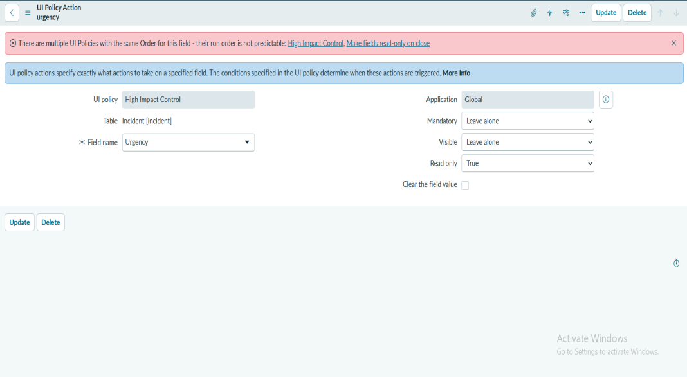

Testing
Testing is manual. After each rule is created, the tester changes the fields on the Incident form, tries to save with missing or invalid data, and checks the browser console. Load time and field response time were also planned as tests. Tools used: ServiceNow Incident form, browser developer console and a timer.
Test ID | Scenario | Expected result | Status
FT-01 | Short description mandatory | Short description is marked mandatory and the incident is not  saved until it is filled. | Pending
FT-02 | Close code / Close notes  mandatory on Resolved | Close code and Close notes become mandatory immediately  and the save is blocked until both are filled. | Pending
FT-03 | Mandatory rule reverses | Close code and Close notes are no longer mandatory; the form  can be saved. | Pending
FT-04 | Show / hide On hold reason | On hold reason appears for On Hold and is hidden for other  States without reloading the form. | Pending
FT-05 | Read-only fields on closed  incident | The controlled fields are read-only and cannot be edited. | Pending
FT-06 | onLoad initial state and guidance | The form opens with the correct default state and shows the  guidance message. | Pending
FT-07 | onChange updates dependent  fields | Dependent fields update only when the user changes the  source field, not while the form is loading. | Pending
FT-08 | onSubmit validation | Invalid data shows a clear message and the save is blocked;  valid data is saved. | Pending
FT-09 | Activate / deactivate rules | The behavior stops when a rule is inactive and returns when it  is active; other rules are unaffected. | Pending
FT-10 | No script errors | No JavaScript errors appear in the console for any rule. | Pending
PT-01 | Form Load Time | Form loads in under 3 seconds. | Pending
PT-02 | Field Change Response | Fields react immediately (under 1 second) without reloading the  form. | Pending
PT-03 | Many Rules on One Form | No slowdown, no conflicting rules and the same values always  give the same behavior. | Pending

Screenshots or Demo
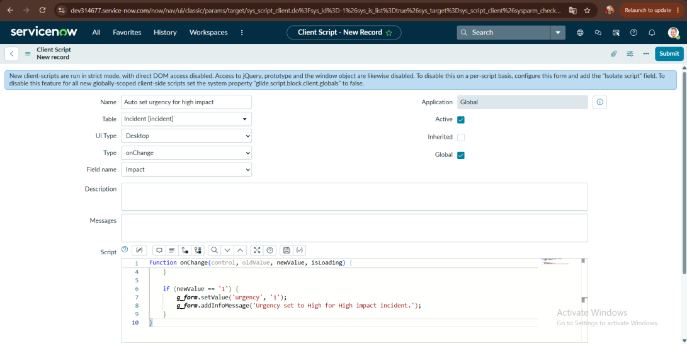
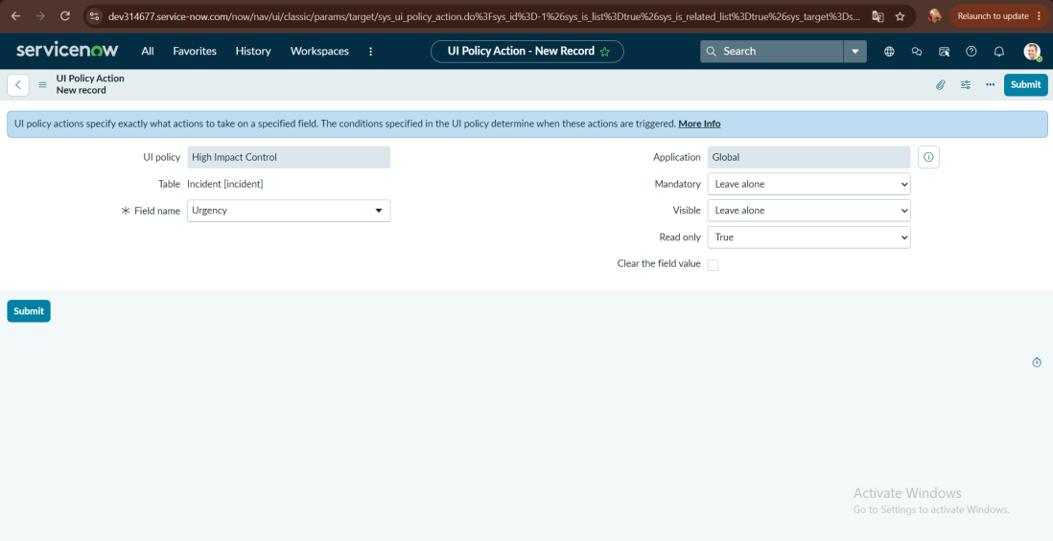
Demo link: https://github.com/<username>/<repository> (replace with your project link)

Known Issues
- UI Policies and Client Scripts run only in the browser form; they do not apply to records created or changed through APIs, imports or server scripts.
- Client-side rules are not a security control; access must still be enforced by roles and ACLs.
- A UI Policy and a Client Script on the same field can conflict, so the order in which they run must be checked.
- Scripts can break if fields or choice values are renamed.

Future Enhancements
- Add Data Policies or Business Rules to enforce the same rules on the server for API and import updates.
- Apply the same patterns to other forms such as Problem and Change.
- Move the rules between instances with update sets.
- Add automated tests (ATF) to verify form behavior after changes.
- Add rules for mobile and Service Portal forms.

